Project Development Phase 2

Date | 31 January 3035
Team ID
Project Name
Maximum Marks | 4 Marks

- Dashborad Screenshot

Dashboard 1 :-

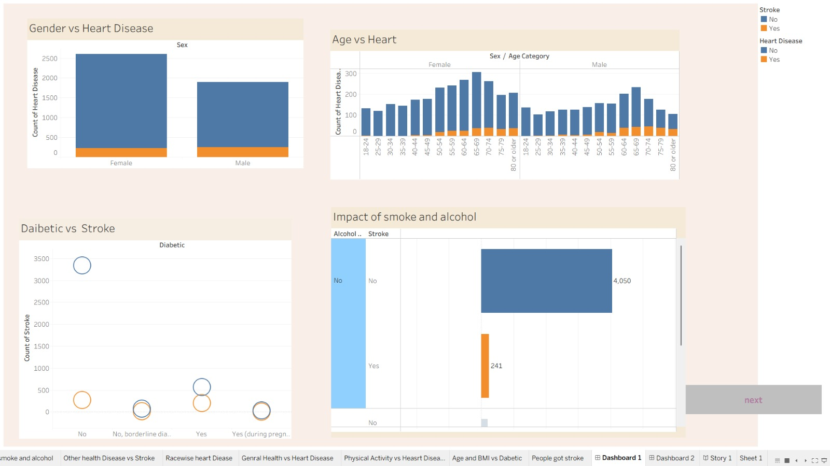

Dashboard 1 public Link :-
https://public.tableau.com/views/Heart_Analysis1/Dashboard13?:language=en-US&publish=yes&:sid=&:redirect=auth&:display_count=n&:origin=viz_share_link

Dashboard 2 public Link :- https://public.tableau.com/views/Heart_Analysis2/Dashboard23?:language=en-US&publish=yes&:sid=&:redirect=auth&:display_count=n&:origin=viz_share_link

Dashboard 2 :-

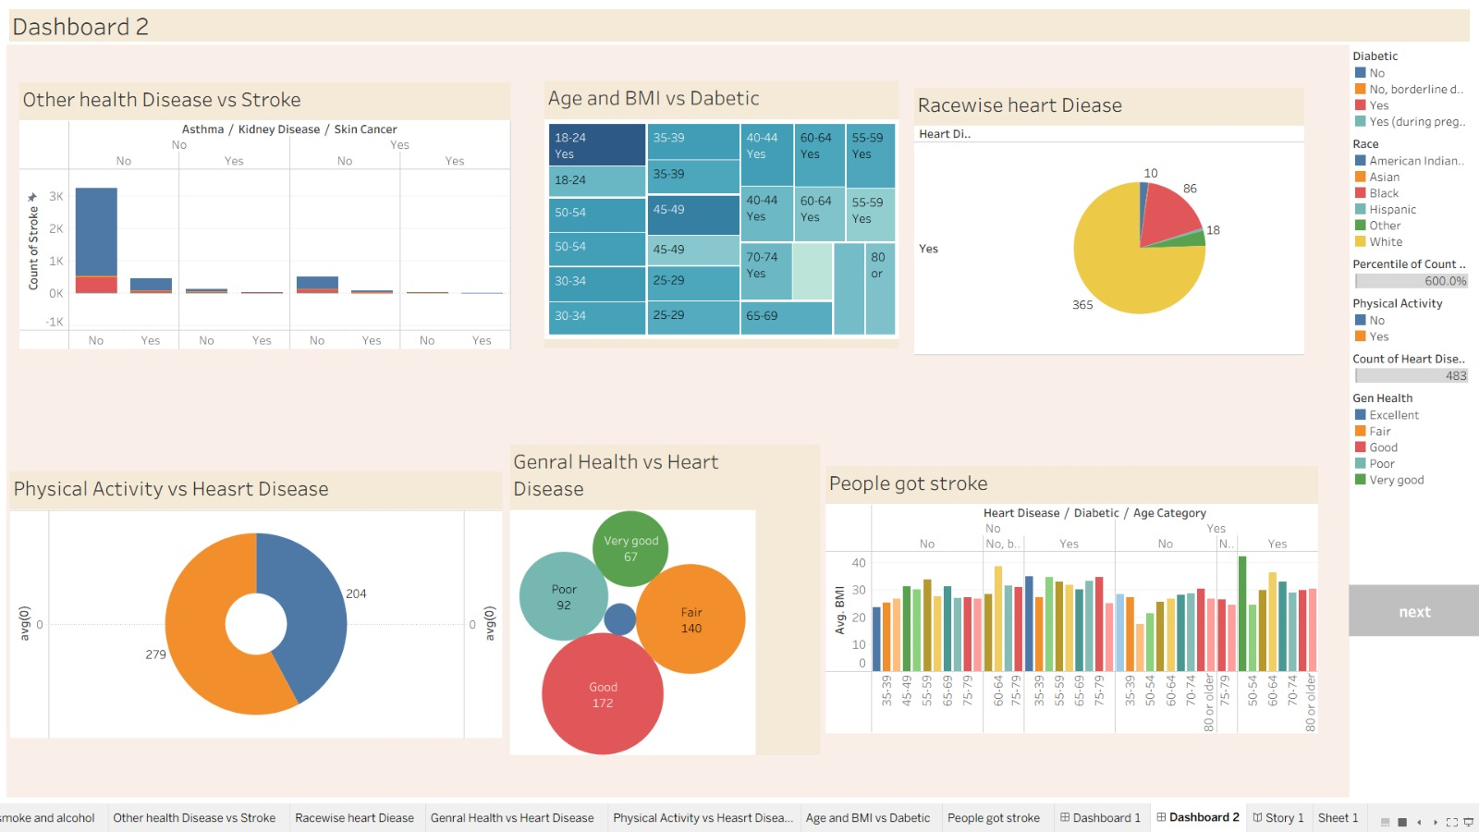

- Story Dataset
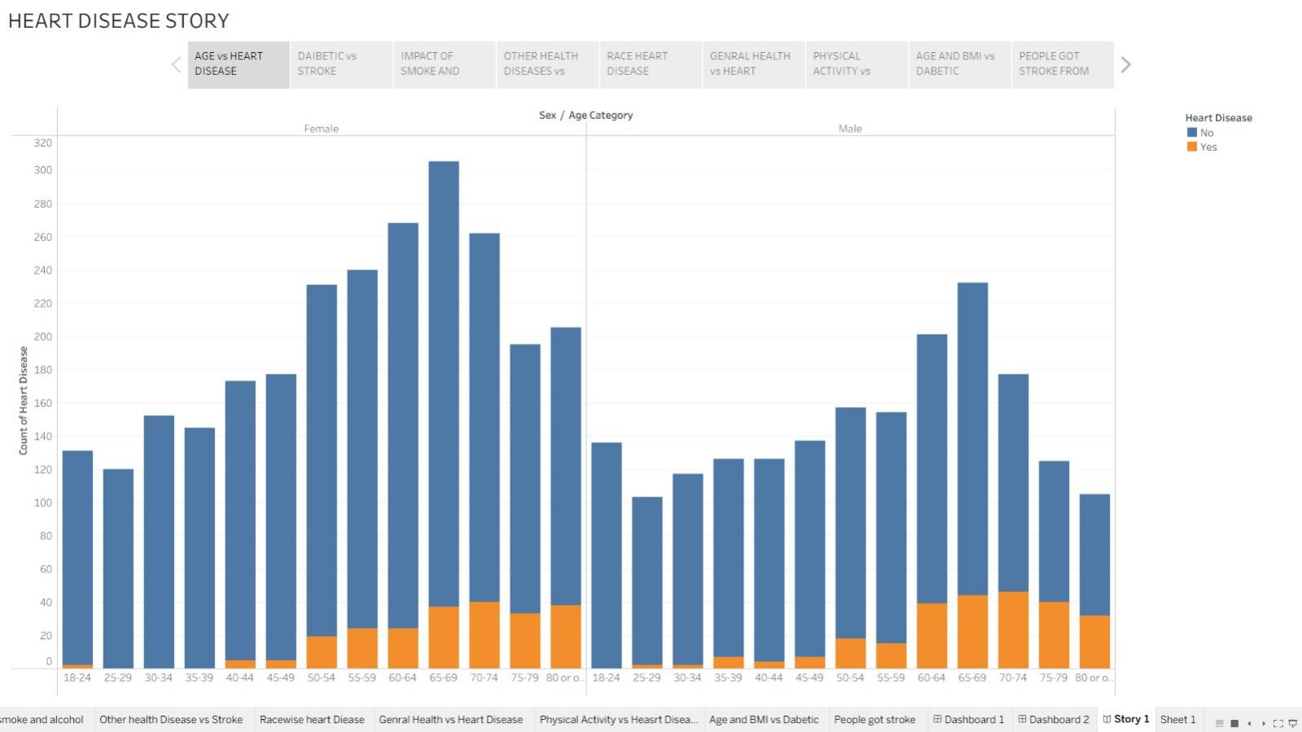

Story Link : https://public.tableau.com/views/Book3_17728828725390/Story1?:language=en-US&publish=yes&:sid=&:redirect=auth&:display_count=n&:origin=viz_share_link

Dataset :- https://drive.google.com/file/d/190Qmq27LeZZ_nWricP3Obl7ys_5otEsp/view

